Ngoc Hoi Secondary school  School year 2017-2018 | WRITTEN TEST ENGLISH 8  The first 45 - minute test
Name: …………………………………………………... Class: ………………… Date: …………
Marks | The teacher’s comment
I Choose and circle the word that has the underlined part pronounced differently. (0.5pt)
- A. precaution B. directory C. emigrate D. message
- A. match B. chore C. school D. choice
II .Choose the word with the different stress syllable. (0.5 pt)
- A. device B. agree C. conduct D. object
- A. assistant B. demonstrate C. arrange D. commercial
III. Choose the best answer to complete the following sentences. (2pts)
- The sun ………….in the east.
- up B. goes C. sets D. rises
- Bao spends his free time doing volunteer work at a local ……………..
- orphanage B. volunteer C. hospital D. school
- The poster is ……….the wall.
- in B. at C. on D. for
- Lan failed the final exam. She ……….. to study harder.
- must B. should C. ought D. will
- Lan is strong ………….. for her to play sports.
- enough B. too C. much D. such
- Tuan isn’t upstair. He is ………...
- outside B. inside C. downstair D. her
- He looks at ………….. in the mirror.
- herself B. himself C. themselves D. myself
- Look at the sky. It ……………. rain
- is going to B. is C. would D. has to
VI. Match each question in A with its answer in B.(1.pt)

A  - What are you going to do this summer vacation?  - Would you like to see a movie?  - What does Nam look like?  - Can I speak to Nancy, please? | B  - No, I did it myself.  - I’m sorry she’s out.  - He’s tall and thin.  - I just watched the movie Romeo and Juliet.  - It’s a bit far from my house. I’m afraid.  - I’m going to visit Nha Trang. | Answer  1 –  2 –  3 –  4 –
V. Reading .(2PTS)
On March 3, 1847, Alexander Graham Ball was born in Edinburgh. He was a Scotsman although he later emigrated first to Canada and then to the USA in the 1870. In America, he worked with deaf-mutes at Boston University. Soon, Bell started experimenting with ways of transmitting speech over a long distance. This led to the invention of the telephone. Bell and his assistant, Thomas Watson, conducted many experiments and finally came up with a device with they first introduced in 1876. Bell said on the phone “Mr.Watson, come here, I want you”. This was the first telephone message. Traveling all over America, Bell demonstrated his invention to the public at countless exhibitions and by 1877 the fist telephone was in commercial use.
- Answer: True ( T )or False ( F ) (1pt)
  - Alexander G.Bell was born in the USA.
  - Bell experimented with ways of transmitting speech between deaf- mutes over a long distance.
- Answer the questions.(1 pt)
- What did Bell do in America?
…………………………………………………………………………………………………………………………..
- What was the first telephone message?
………………………………………………………………………………………………………………………….
- Who was Thomas Watson?
………………………………………………………………………………………………………………………….
- What did Bell invent ?
…………………………………………………………………………………………………………………………..
VI. .Do as directed in parentheses ( 2pts)
- Children mustn’t play in the kitchen because it is very dangerous. ( make a question for the underlined words)
………………………………………………………………………………………………………………………….
- They plan to collect used glass, paper and cans and send them for recycling. ( Use ‘be going to’)
…………………………………………………………………………………………………………………….
- like / would / you / to / leave/ message / her. ( reorder the word into complete the sentence)
…………………………………………………………………………………………………………………………
- The boy is too young to go to the cinema by himself. ( Use ‘old’instead of ‘young’)
……………………………………………………………………………………………………………………….
VII . Listen ( 2pts )
Part: 1.2 /M :7
Listen and write. There is one example.(1PT)
Name:………….. LUCY Flynn…………………..
1. Which class?.......................................................................................................................................
2. When? Suturday………………………………………………………………………………….
3. Name of teacher?...................Mr…………………………………………………………………….
4. Comes to Centre by………………………………………………………………………………….
5. Favourite sport:……………………………………………………………………………………..
Part 2.4/ F 3
Listen and tick (V) the box. There is one example. (1PT)
. What time did school finish? 1 . which is Sarah’s favorite lesson ?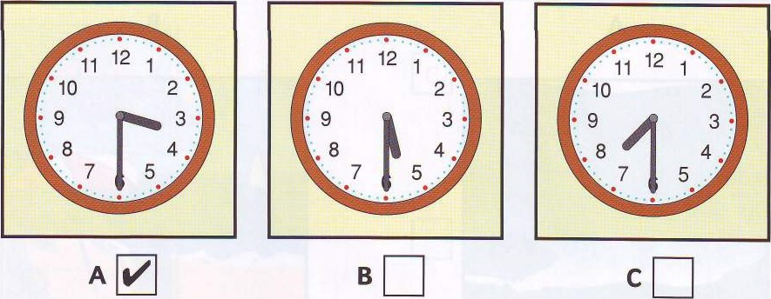 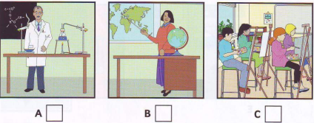2. Which girl is Sally? 3. Which team is Sarah In?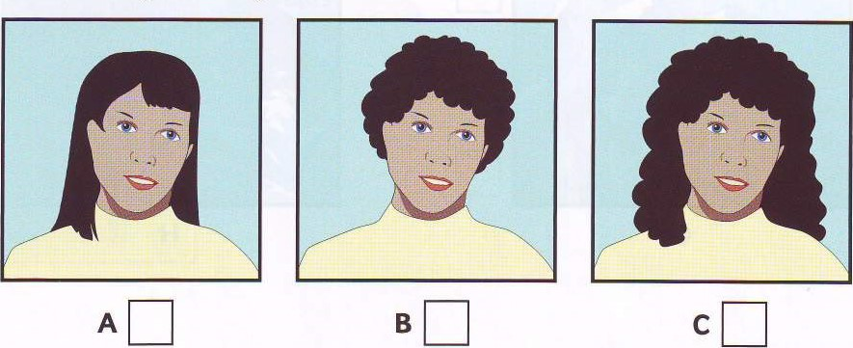 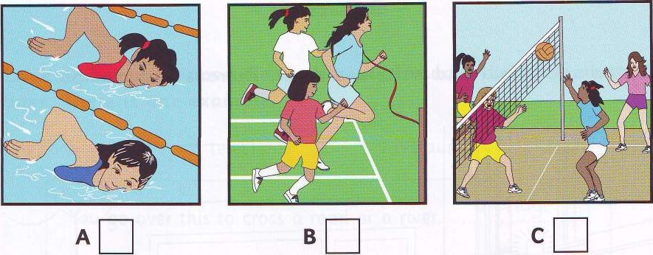
4 what did Sarah have for lunch ? 5. What is Sarah going to do next?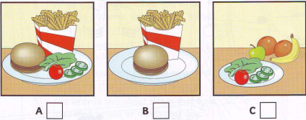 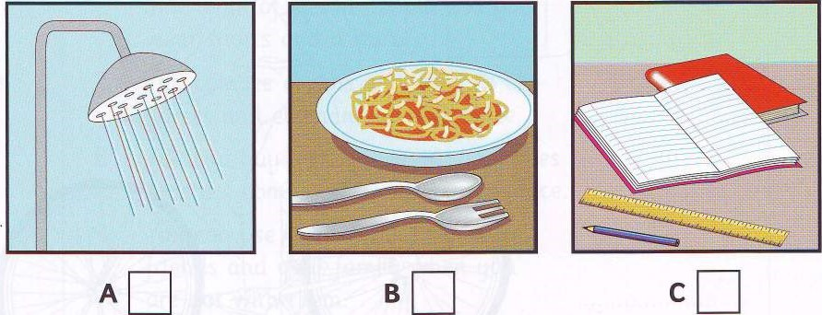
KEY 2017-2018
I.Choose and circle the word that has the underlined part pronounced differently. (0.5pt)
  - A 2. C
II.Choose the word with the different stress syllable. (0.5 pt)
  - D 2. B
III.Choose the best answer to complete the following sentences. (2pts)

1– D | 2- A | 3- C | 4- C
5- A | 6- C | 7- B | 8- A
IV.Match each question in A with its answer in B.(1.pt)

- G | - F | - C
- B

V.Read.
- Answer: True ( T )or False ( F ) (1pt)
1.F 2. T
- Answer the questions.(1. pt)
1.In America, he worked with deaf-mutes at Boston University.
2. “Mr.Watson, come here, I want you” was the first telephone message.
3. He was Bell’s assistant.
4. Bell invented the telephone.
VI. Do as directed in parentheses ( 2pts)
1.Why mustn’t children play in the kitchen?
2. They are going to collect used glass, paper and cans and send them for recycling
3. Would you like to leave her message?
4. The boy isn’t old enough to go to the cinema by himself.
VII LISTEN (2PTS)
PART 1.2 /M7 (1PT)
1. Swimming 2 afternoon (s) 3 Hart 4 (her father’s/dad’s )car 5. Tennis
PART 2.4 / F3 (1PT)
1B 2C 3A 4B 5A

